**Support / Info For Ukrainian Refugees**

**○ Parent and Carers Guide to School Applications : Tusla Education Support Service (TESS)**



TESS have prepared a guide for parents and carers regarding how to apply for school places. The document is available in English and Ukrainian and will soon be available in Russian. See sample below.

**NOTE** : These documents are available to download in the “Resources” section of Wexford CYPSC website, to access click [here](http://www.wexfordcypsc.ie/resources).

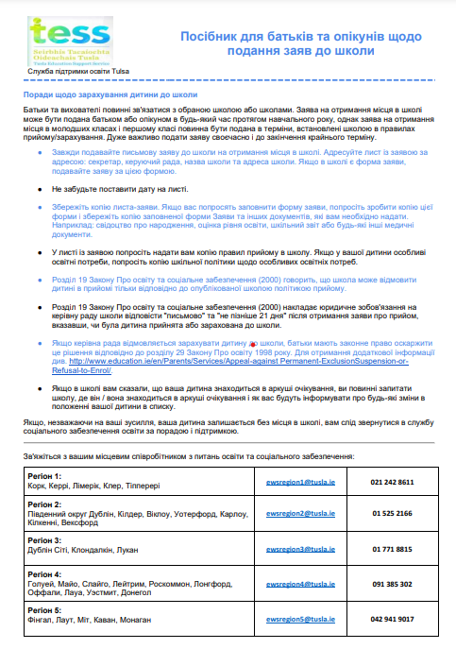

**○ Psychological and Trauma Resources : HSE**

The following documents might be helpful for dissemination to those providing initial services to the Ukrainian refugees arriving into the South East.

* Overcoming psychological effects of Trauma, taken from the Clonea In-Reach Primary Health Care Model re Refugees
* Psychology resource document

**NOTE** : These documents are available to download in the “Resources” section of Wexford CYPSC website, to access click [here](http://www.wexfordcypsc.ie/resources).

**○ Information on healthcare services for Ukrainian nationals**

Ukrainian nationals arriving in Ireland are able to get up to date information about accessing health services at [www.hse.ie/Ukraine](https://scanner.topsec.com/?d=2039&t=b2c3241cd95f3e9b0141e14ddf4ecd67f853e16d&u=www.hse.ie%2FUkraine&r=show) .

The HSE will update this page often and will be providing information in English, Ukrainian and Russian languages.

Please feel free to circulate this information.

Kind regards,

**Suzanne Nolan, Regional Roma Health Lead;**

HSE Social Inclusion South East Community Healthcare (SECH), Gorey Health Centre, Hospital Grounds, Gorey, Co. Wexford; Eircode: Y25N5K6

**Mobile: 087 6468856; E:** [**suzannes.nolan@hse.ie**](mailto:suzannes.nolan@hse.ie)